NSW Department of Education & Training |  | 2213
2010 Annual School Report
IVANHOE CENTRAL SCHOOL
NSW Public Schools – Leading the way
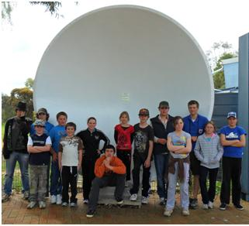
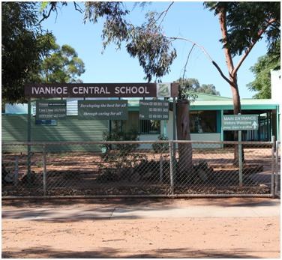
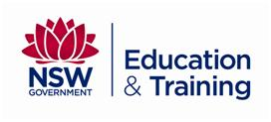
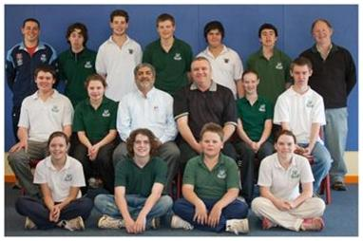
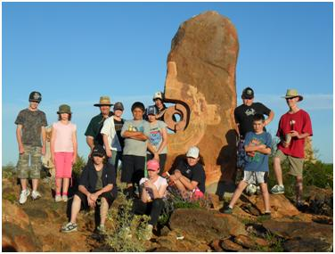
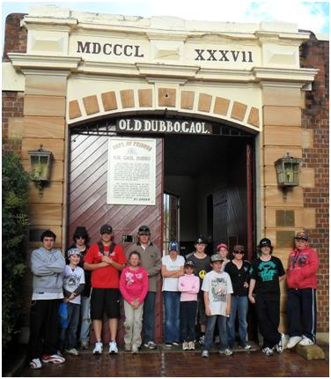
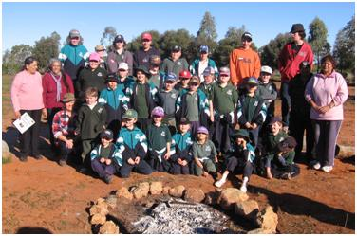
Principal’s message
This report outlines the major achievements of the school during 2009 and provides parents with a comprehensive progress report on all aspect of the school.
I certify that the information in this report is the result of a rigorous school self-evaluation process and is a balanced and genuine account of the school’s achievements and areas for development.
Gordon Hay
P & C and/or School Council message
The P & C continue to support the school through such activities as:
- Fund raising, such as the Mother’s Day and Father’s Day stalls, Fun Run and the Melbourne Cup luncheon.
- Donations to the school excursion fund.
Irene Eyre
Ivanhoe Parent and Citizens Association
Student information
It is a requirement that the reporting of information for all students must be consistent with privacy and personal information policies.
Student enrolment profile
At the time that these figures were submitted the school had a total enrolment of 31 students. This has since increased to 41. This is actually an increase on previous years.
Primary
 | 2006 | 2007 | 2008 | 2009 | 2010
Male | 14 | 15 | 10 | 12 | 9
Female | 18 | 16 | 17 | 19 | 12
Secondary
 | 2006 | 2007 | 2008 | 2009 | 2010
Male | 6 | 7 | 7 | 3 | 2
Female | 4 | 2 | 2 | 9 | 9

Student attendance profile

The attendance rates have remained over 90% and continues to be above the region and State figures. With such a small cohort the figures will fluctuate due to the attendance patterns of a very small number of students.
Management of non-attendance
Regular attendance at school is fundamental to the success and well being of students. The school engages in regular evaluations of roll marking and attendance monitoring procedures. Through the use of the Home School Liaison Officer, the Aboriginal Schools Liaison Officer, the Aboriginal Education Officer and staff the school quickly responds to support students with attendance issues.
Class sizes
In March 2003 the Government announced its commitment to publish primary class sizes in annual school reports in order to provide parents with as much local information as possible.
The following table shows our primary class sizes as reported at the 2010 class size audit conducted on Wednesday 17 March 2010.
Roll Class | Year | Total per Year | Total in Class
K-2 | K | 3 | 9
K-2 | 1 | 2 | 9
K-2 | 2 | 4 | 9
3/4 | 3 | 6 | 9
3/4 | 4 | 3 | 9
5/6 | 5 | 3 | 8
5/6 | 6 | 5 | 8
Class sizes are well below the maximum class size allowable.
Structure of classes
Where possible, classes are combined into K-2, 3-4, and 5-6 for Primary. Secondary classes are combined into 7-8, 9-10, 11, and 12.
Retention to Year 12
Due to the small number of enrolments at Ivanhoe Central School the retention rates from the Year 10 to Year 12 are not applicable.
Post-school destinations
There were no Year 12 students attending Ivanhoe Central School in 2010.
Year 12 students undertaking vocational or trade training
There were no Year 12 students attending Ivanhoe Central School in 2010.
Year 12 students attaining HSC or equivalent vocational educational qualification
Year 11 and Year 10 students achieved HSC qualifications in Metals and Engineering and Construction due to participating in Frameworks Courses.
Staff information
It is a requirement that the reporting of information for all staff must be consistent with privacy and personal information policies
Staff establishment
Position | Number
Principal | 1
Deputy Principal(s) | 0
Assistant Principal(s) | 1
Head Teachers | 1
Classroom Teachers | 4
Teacher of Emotional Disabilities | 0
Teacher of Mild Intellectual Disabilities | 0
Teacher of Reading Recovery | 0
Support Teacher Learning Assistance | 0
Teacher Librarian | 0
Teacher of ESL | 0
Counsellor | 0
School Administrative & Support Staff | 4
Total | 11
The school employs an Aboriginal Education Officer on a full time basis. A tutor is employed through the Norta Norta Program to assist Aboriginal students on a part time basis.
Staff retention
All staff were retained from 2009.
Teacher qualifications
All teaching staff meet the professional requirements for teaching in NSW public schools.
Qualifications | % of staff
Degree or Diploma | 100
Postgraduate | 0
Financial summary
This summary covers funds for operating costs and does not involve expenditure areas such as permanent salaries, building and major maintenance.
Total income for 2010 was $439,754.66. Included in this amount was $207,778.19 which was the balance brought forward from 2009.
Global funds entitlements of $116,708.38 are the government’s funds for general use.
Tied Funds entitlements of $70,581.67 are for special programs and during 2010, $95,214.88 were spent on designated programs.
Active After School Communities sport program continued of operate throughout the whole school year and is of great value to the students. The Premier’s sporting challenge is ongoing and is providing the school with new sporting equipment. The Early Childhood hub has continued to operate throughout the year. The school has also been part of the Low SES Program this year which made extra funding available to employ two part time staff.
Years 5/9 enjoyed a Cultural Enrichment excursion to Broken Hill, funded by the Country Area Program. Whilst there, Year 6 students were able to visit Willyama High School to get an idea of what High School would be like in a larger town. This was part of the Transition to Year 7 program.
Computer co-ordination funding has been used to supply our school with up to date technology including a new server, public address system and a state-of-the-art combined still/video camera.
A new tutoring program for Aboriginal students was introduced this year call Norta Norta, which enabled the school to employ a casual tutor. The Far West Vocational Education Program and School to Work Program provided funding to help pay for the construction of a storage shed which the VET students have been working on.
School and Community funds came primarily from excursions. The major excursion for the years 4-10 was to Dubbo, with visits to Parkes and Wellington.
Library staff held another successful Scholastic Book Fair. The school continues to sell uniforms to students and the school bus is available for hire to the community. The school hall was hired by the Australian Electoral Commission for the Federal election. The old school bus was traded in for a new one. Donations were received from various people and organizations.
The school is the custodian for all trust accounts. The school collects money from students and parents and orders books from the Scholastic Book Club. The Life Education Van visited the school once again and St Vincent de Paul donated money for an end of year Christmas lunch for the students. The Heart Foundation Jump Rope for Heart was held as a charitable event to raise money and promote healthy challenges.
The major items of expenditure in the Teaching and Learning area were the Key Learning Areas which are the faculty budgets. Training and Development which is professional development courses for staff and tied funds for special programs. The school continues to lease a Mitsubishi Pajero to attend professional development courses.
Administration and Office consists of requisitions of school and office supplies. The Principal’s welfare dissection has been used for catering purposes on special occasions during the year, eg morning tea for parents after school assemblies, school concert, and Senior Citizen’s Day. The Primary and Secondary Departments purchase from their requisition budgets what equipment they need. Paper is ordered as required and GST paid to suppliers has been recouped from the ATO. Payment for this category have been for registration, insurance and services for the bus and trailer. The school continues to pay its own bank fees under the agreement with Westpac. This year we also employed a casual mentor for Year 11 students enrolled in the Wilvandee Access Program.
Utilities are running costs of the school. Electricity has risen due to increased charges from AGL. Water usage was down due to continual monitoring for leaks and wastage.
Maintenance involves repairs to buildings and grounds. Capital programs are assets which have a value of $5000.
A full copy of the school’s 2010 financial statement is tabled at the annual general meetings of the School Council and/or the parent body. Further details concerning the statement can be obtained by contacting the school.
School performance 2010Achievements
Arts
Creative and Performing Arts are interrelating in all key learning areas:
Some the major activities were:
- Easter Art Week
- Connected classroom linkups such as the Great Barrier Reef, Belonging Day with Granville South High and dog sleds in Alaska.
- Christmas craft
- NAIDOC Week celebrations
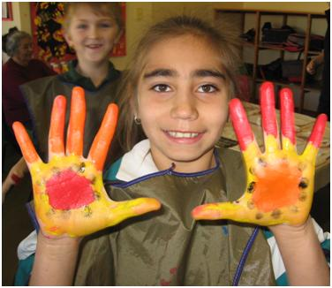
- Scotland posters for the Country Women’s Association country study day.
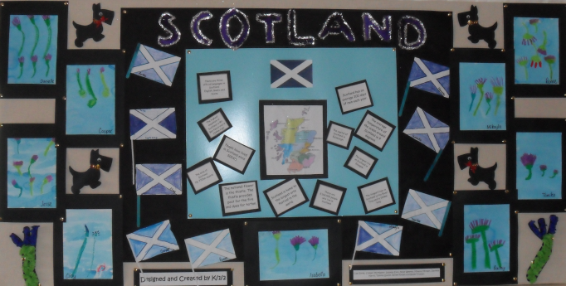
Sport
Sport is a major focus for both school and community. The sporting programs were interrupted by rain and so the Swimming Carnival, Wilvandee Sports and the Swimsafe Program could not be run. However, other sporting events were:

- Active After School Sports
- Quality Sports
- Cross Country
- Sport and Recreational Coaching Clinics
- Athletics Carnival
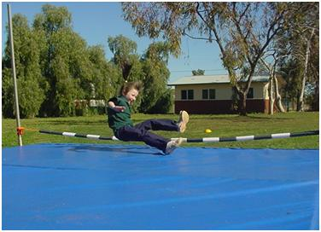
Other
- Healthy Lunches
- Breakfast Club
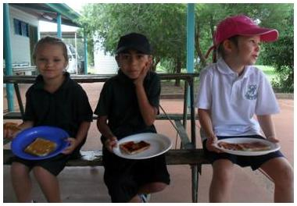
- Fruit Break
- Disco
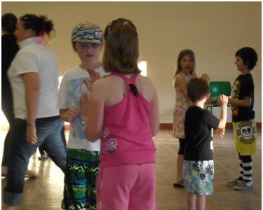
Excursions
- 5-10 Cultural Enrichment Excursion
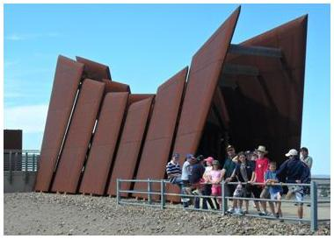
- TVET Outdoor Recreation Camp
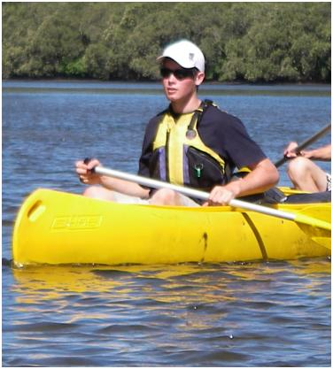
- 4-10 Dubbo Excursion
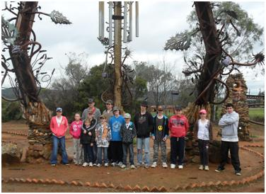

K-2 visit to the Police Station
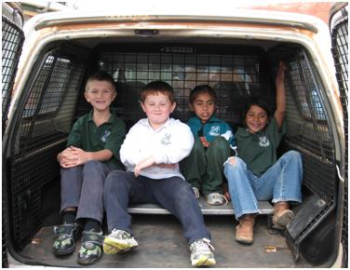
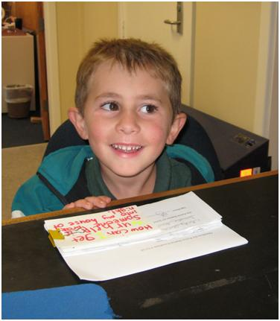
Academic
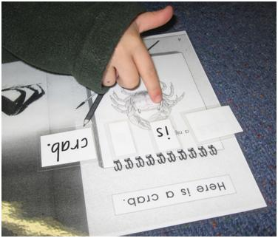
In the National Assessment Program, the results across the Years 3, 5, 7 and 9 literacy and numeracy assessments are reported on a scale from Band 1 to Band 10.
The achievement scale represents increasing levels of skills and understandings demonstrated in these assessments.
Yr 3: from Band 1 (lowest) to Band 6 (highest for Year 3)
Yr 5: from Band 3 (lowest) to Band 8 (highest for Year 5)
Yr 7: from Band 4 (lowest) to Band 9 (highest for Year 7)
Yr 9: from Band 5 (lowest) to Band 10 (highest for Year 9)
and/or
In the School Certificate the performance of students is reported in performance bands ranging from Performance Band 1 (lowest) to Performance Band 6 (highest).
Literacy – NAPLAN Year 3
Five Year 3 students attempted the NAPLAN test in literacy in 2010.
Numeracy – NAPLAN Year 3
Five Year 3 student attempted the NAPLAN test in numeracy in 2010.
Literacy – NAPLAN Year 5
Two Year 5 students attempted the NAPLAN test in literacy in 2010.
Numeracy – NAPLAN Year 5
Two Year 5 students attempted the NAPLAN test in numeracy in 2010.
Literacy – NAPLAN Year 7
Three Year 7 students attempted the NAPLAN test in literacy in 2010.
Numeracy – NAPLAN Year 7
Three Year 7 students attempted the NAPLAN test in numeracy in 2010.
Literacy – NAPLAN Year 9
Four Year 9 students attempted the NAPLAN test in literacy in 2010.
Numeracy – NAPLAN Year 9
Four Year 9 students attempted the NAPLAN test in numeracy in 2010.
Progress in literacy
Average progress in literacy is not shown where the results are for less than ten students.
Progress in numeracy
Average progress in numeracy is not shown where the results are for less than ten students.
School Certificate
Two students sat for the School Certificate in 2010.
School Certificate relative performance comparison to Year 5 (value-adding)
The School Certificate relative performance comparison to Year 5 could not be shown as the results are for less than ten students.
Higher School Certificate
No student sat for the HSC in 2010.
Higher School Certificate relative performance comparison to School Certificate (value-adding)
The Higher School Certificate relative performance comparison to School Certificate could not be shown as the results are for less than ten students.
Minimum standards
The Commonwealth Government sets minimum standards for reading, writing, grammar and punctuation, spelling and numeracy for years 3, 5, 7 and 9.
The performance of the students in our school in the National Assessment Program – Literacy and Numeracy is compared to these minimum standards. The percentages of our students achieving at or above these standards are reported below.
Percentage of Year 3 students in our school achieving at or above the minimum standard in 2010
Percentage of Year 3 students in our school achieving at or above the minimum standard in 2010 is not shown as the results are for less than ten students.
Percentage of Year 5 students in our school achieving at or above the minimum standard in 2010
Percentage of Year 5 students in our school achieving at or above the minimum standard in 2010 is not shown as the results are for less than ten students.
Percentage of Year 7 students in our school achieving at or above the minimum standard in 2010
Percentage of Year 7 students in our school achieving at or above the minimum standard in 2010 is not shown as the results are for less than ten students.
Percentage of Year 9 students in our school achieving at or above the minimum standard in 2010
Percentage of Year 9 student in our school achieving at or above the minimum standard in 2010 is not shown as the results are for less than ten students.
Significant programs and initiatives
Aboriginal education
Ivanhoe Central School has continued to provide support for Aboriginal students and to provide programs designed to educate all students about Aboriginal history, culture and contemporary Aboriginal Australia.
A key focus has been recognizing Aboriginal achievement amongst students expanding all student’s cultural awareness. NAIDOC Week celebrations included traditional art workshops. A secondary student also attended work experience at Lake Mungo National Park.
Multicultural education
The school has maintained a focus on multicultural education in all areas of the curriculum by producing programs which develop the knowledge, skills and attitudes required for a culturally diverse society.
Respect and responsibility
At Ivanhoe Central School students are taught to respect each other, staff, parents and property. The students are encouraged to become responsible for their own actions. Measures to promote respect and responsibility are:

- ANZAC Day
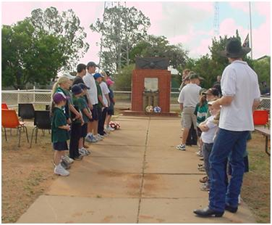
- Remembrance Day
- Jump Rope for Heart
- SASS Recognition Week
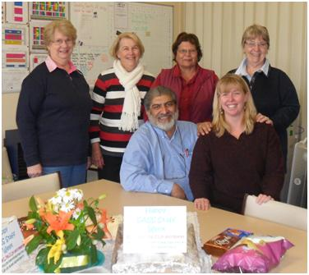
Biggest Morning Tea
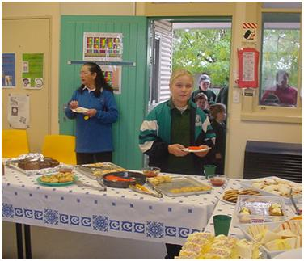

Country Areas Program (CAP)
CAP provides the school with support to initiate programs that assist the teachers to deliver quality programs to improve student learning outcomes and opportunities. CAP funds were used to enhance teaching and learning through:
- Aboriginal Cultural Awareness – to increase awareness of Aboriginal culture by inviting guest speakers, painters, and dancers to perform at the school.
- Reading to Learn Support – to support the implementation of the Reading to Learn Program across all classes at Ivanhoe Central School.
National partnership programs
- Differentiated Professional Learning Program in literacy.
- Basic progress has been made towards achievement of goals. Individual Learning Plans have targeted areas and students in need.
- Further teacher Professional Learning in explicit literacy strategies and demonstrations needed.
- Ongoing support from regional consultants and other professionals is essential for ICS’s young and inexperienced staff.
- Implementing focused programs throughout the school in literacy.
- Basic progress has been made towards achievement of goals. NAPLAN data indicates growth for all students.
- Further individualised instruction needed for targeted students
- Continued use of a teacher 0.3 days a week and teacher aide needed to achieve targets.
- Identification of staff professional learning needs and planned individual programs to ensure implementation of quality teaching framework in numeracy in all classes.
- NAPLAN data indicate increasing percentage of students progressing towards individual goals.
- Further individual programs needed for targeted students.
- Use of a teacher aide will enhance Quality Teaching programs.
- Connected learning.
- Teachers access professional learning opportunities to effectively utilise ICT.
- Classroom programs indicate teaching strategies which make appropriate use of technology.
- Teacher access to and capacity to use ICT in teaching strategies is enhanced and evident in learning activities.
- Student access to, and capacity to use ICT in their learning is enhanced leading to improved student engagement and learning outcomes across Key Learning Areas (KLA’s).
- Observation of classroom practice indicates more effective usage of interactive technology in teaching and learning.
Vocational Education and Training
- All students in Year 10 have chosen Vocation Education pathways. This trend has continued from the previous two years. The courses being offered are Metals and Engineering and Construction. TAFE provided an evening course for Metals and Engineering which was accessed by students. It is a frameworks course which means it will count towards their Year 12 course. Construction was conducted every second Friday during school time and counted towards the Year 11 preliminary course. As part of their construction course the students have built a small storage shed on the school grounds. This construction work was also the basis of the student’s work placement. A Sport and Recreation unit was also attended by a student in 2010 which will count towards his Year 11 certificate.
- TAFE Construction
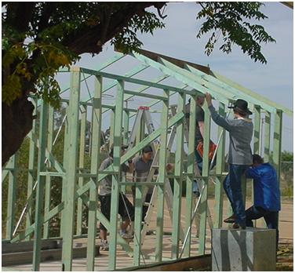
Building Education Revolution building
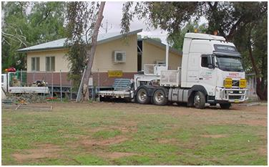
As part of the Commonwealth Governments Building Education Revolution, Ivanhoe Central School received a Home Base in 2010 which was installed on the school grounds and will be used as a classroom.
Progress on 2010 targets
Target 1
Consolidation and Development of Higher Level Results in Literacy
Our achievements include:
- Teacher aide employed to assist students.
- Improved NAPLAN results in reading, grammar and spelling
- Students reading at or above chronological age.
Target 2
Consolidation and Development of Higher Level Results in Numeracy
- Our achievements include:
- Students are achieving a level of growth at or above the National Minimum Standards.
- Students are using Mathematical language to derive and answer.
- Students are achieving stage appropriate outcomes.
Target 3
To diminish the gap in literacy and numeracy achievement between Aboriginal students and all students
Our achievements include:
- All Aboriginal students have a Personal Learning Plan in place.
- A tutor was employed to help individual Aboriginal students.
- Aboriginal Education Policy strategies were evident in class programming.
Key evaluations
It is a requirement for all NSW public schools to conduct at least two annual evaluations – one related to educational and management practice and the other related to curriculum. In 2010 our school carried out evaluations of:
Educational and management practice
School Leadership
Background
Each year the school undertakes an evaluation of one of the six areas of planning, leadership, management, culture, teaching and learning. In 2010, leadership was chosen as the educational and management practice to be evaluated.
Findings and conclusions
The surveys that were returned produced the following results.
Students were generally positive about school leadership, improvement and communication with the majority of responses falling into almost always or usually responses. Almost 80% of students stated that school leaders usually understood the school and get the best from staff and students.
- The highest rating of student responses (87% almost always) thought that the school involves all groups within the school community in deciding what it is aiming to achieve.
- The response to the statement that ‘School leaders value the contributions of individuals and groups and is always looking for ways to improve’ was spread fairly evenly over almost always and usually.
- The question of whether school leaders are open to new ideas had a 73% almost always response.
- There were no responses in the rarely category.
Staff were generally positive with all of their responses falling into the almost always or usually category. The most highly rated areas were:
- School leaders build relationships based on trust, collegiality and mutual respect.
- School leaders ensure that all members of the school community are treated fairly.
- School leaders model commitment to school improvement.
- Leaders ensure that all groups within the school community develop the statement of school’s purpose.
- Staff, parents and students are encouraged to take leadership roles at the school.
- School leaders inspire and motivate learners.
Parents were also very positive about school leadership.
- 100% of the parents surveyed thought that the school leaders understand the school and get the best from staff and students and encourage leadership roles at the school.
- The question of school leadership and their capacity to initiate improvement in general received positive responses.
Future directions
The school leadership received a positive response from staff, students and parents. The capacity for the school leadership to initiate change received a similar positive response with the students being more evenly spread between almost always and usually. There is a perceived need to continue to communicate and initiate improvement and new ideas through closer contact with the students through such things as the weekly bulletin, daily and weekly assemblies and improved student involvement in school activities and the parents through the P & C and parent-teacher interviews.
Curriculum
Student Writing and Spelling
Background
Schools undertake periodic evaluations of all programs. In 2010 the school looked at the student Writing and Spelling Program.

Findings and conclusions
The students were generally positive in their responses.
- All students agreed that the teacher tells them why they are doing writing tasks and how important writing and spelling is.
- The areas where there was disagreement were: I include challenging words in my writing; I learn spelling rules each week and I know about the different text types
- Only one student indicated that they did not enjoy writing.
The staff were all positive in their responses. The main outcomes were:
- While both teaching and writing can be taught effectively in isolation, teaching them simultaneously has a greater meaning for students and therefore spelling rules and grammar are retained more easily.
- Clear expression of language is essential for accurate communication.
- There is an overall perception that students are improving in writing and reading.
Parents were also positive and indicated strong satisfaction with the progress of their child in writing and spelling.
Future directions
The school needs to continue its program of writing and spelling with emphasis on the early years. A teacher aide is provided to support these early years. A teacher aid is also provided for remedial support for secondary students. The students generally enjoy reading and are encouraged by their ability to progress and have their progress recognized. Both staff and parents are supportive of current programs and are pleased with the progress evident in the student’s reading and spelling abilities.
Parent, student, and teacher satisfaction
In 2010 the school sought the opinions of parents, students and teachers about the school.
Community satisfaction is very positive with parents strongly agreeing that the school has the students as the main focus with supportive welfare programs. The school newsletter is very informative and the Annual School Report provides important information about the school. The school is a safe and secure environment and is regularly reviews its policies. The school regularly praises and rewards students when successful. The parents believe students are the school’s main focus.
Professional learning
Ivanhoe Central School expended $11 833.85 in training and development funds. Staff participated in a wide range of professional learning activities such as: Guidelines for the Safe Conduct of Sport and Physical Activity in Schools; Quality Teaching; Mathletics Training; Anlaysis of Smart Data; Aboriginal Education Policy; DET Online Resources Overview; Technology in the Workplace; Jolly Phonics Training; Fizzics Education; Reading to Learn Updates; Grant Writing Workshop; Code of Conduct Update; and Child Protection Update. An increasing use is being made of video conferencing to overcome the disadvantage of distance and the disruption teacher absences cause to school routines.
School development 2009 – 2011
The school’s role in the community is a pivotal one, providing and supporting many services that would be otherwise unavailable. As part of the annual school management, planning for the coming year and beyond is carried out by staff. In 2010 this supported by a comprehensive Situational Analysis of the school as required by the National Partnership funding arrangements
Targets for 2011
Target 1
Increased student average scaled growth in text type writing to a level comparable to the state based on NAPLAN in 2011
Strategies to achieve this target include:
- Teacher to be employed 0.3 days a fortnight for assessment and remedial work with targeted students.
- Teacher aides providing provide support to targeted classes and students.
- Area office consultants in Quality Teaching and Learning Assistant to providing support for staff.
Our success will be measured by:
- Improved NAPLAN results in literacy.
- All students will be reading at or above their chronological reading age.
Target 2
Raise average scaled growth rates in numeracy comparable to region and state levels based on NAPLAN in 2011.
Strategies to achieve this target include:
- Teacher to be employed 0.3 days a fortnight for assessment and remedial work with targeted students.
- Teacher aides providing provide support to targeted classes and students.
- Area office consultants in Quality Teaching and Learning Assistant to providing support for staff.
Our success will be measured by:
- Improved NAPLAN results in numeracy.
- All students will be progressing towards individual goals.
Target 3
Increasing percentage of average literacy and numeracy of Aboriginal students to exceed state average in 2011.
Strategies to achieve this target include:
- All Aboriginal students to have a Personalised Learning Plan.
- Aboriginal Education Officer providing provide support to targeted classes and students.
- Area office consultants in Quality Teaching and Learning Assistant to providing support for staff.
Our success will be measured by:
- Improved NAPLAN results in numeracy.
- All Aboriginal students will be progressing towards individual goals.

About this report
In preparing this report, the self-evaluation committee has gathered information from evaluations conducted during the year and analysed other information about the school's practices and student learning outcomes. The self-evaluation committee and school planning committee have determined targets for the school's future development.
Gordon Hay Principal
Vishnu Maharaj Head Teacher
Mark Densmore Assistant Principal
School contact information
Ivanhoe Central School
Columbus Street, Ivanhoe. 2878
Ph: 02 6995 1108
Fax: 02 6995 1290
Email: ivanhoe-c.school@det.nsw.edu.au
Web: http://www.ivanhoe-c.schools.nsw/edu.au
School Code: 2213
Parents can find out more information about Annual School Reports, how to interpret information in the reports and have the opportunity to provide feedback about these reports at:
http://www.schools.nsw.edu.au/asr

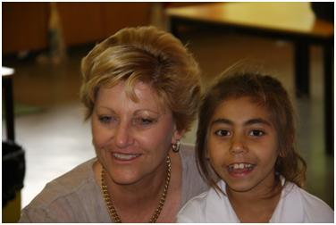
Visit by the Regional Director of Western NSW, Carol McDiarmid

